H.T No
Regulations:
A15


Sreenidhi Institute of Science and Technology
(An Autonomous Institution)
Code No: 5A242 Date: 05-Jan-2019 (FN)

B.Tech I-Year II-Semester End External Examination, Dec-2018/Jan-2019 (Supplementary)
NETWORK ANALYSIS (ECE and ECM)
Time: 3 Hours Max.Marks:75

Note: a) No additional answer sheets will be provided.
b) All sub-parts of a question must be answered at one place only, otherwise it will not be valued.
c) Missing data can be assumed suitably.

Part - A Max.Marks:25

Answer all QUESTIONS.

1. | Define independent and dependent sources. | [3M]
2. | Define a dual network. | [3M]
3. | Define form factor and crest factor of a sinusoidal waveform. | [3M]
4. | State maximum power transfer theorem. | [3M]
5. | Draw the Z-parameter equivalent circuit of a two port network. | [3M]
6. | Explain the time constant of a series R–L circuit. | [2M]
7. | Explain the relationship between band width and quality factor. | [2M]
8. | Define cut set and tie set. | [2M]
9. | State super position theorem. | [2M]
10. | List out different types of frequency selective filters. | [2M]

Part – B Max.Marks:50
ANSWER ANY FIVE QUESTIONS. EACH QUESTION CARRIES 10 MARKS.

11. | a) | Derive the equation for the equivalent of ‘n’ capacitors when they are connected in parallel? | [4M]
 | b) | Determine the current through 5Ω resistor in the below Fig.1 using Nodal Analysis  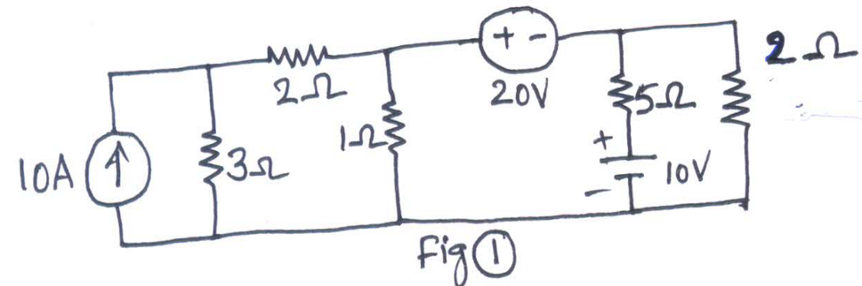 | [6M]
12. | a) | Explain the procedure to obtain the dual of a given network. | [4M]
 | b) | Obtain the basic cut set matrix for the given graph in Fig. 2 below by taking 1,2,3 as tree branches.  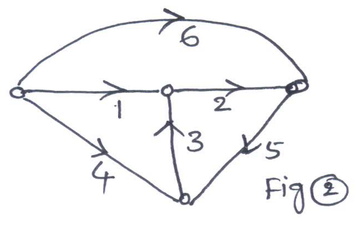 | [6M]
13. | a) | What is resonance in a series RLC circuit? List out the characteristics of a series RLC circuit under resonance. | [4M]
 | b) | A series circuit consisting of 10Ω resistor, 10mH inductor and a 100µF capacitance is driven by a 50Hz A.C. voltage source of 100V. Calculate the equivalent impedance, current in the circuit, the power factor and power dissipated in the circuit. | [6M]
14. | a) | State and explain Norton’s theorem. | [4M]
 | b) | Determine the current though 5Ω resistor in below Fig. 3 by using Thevenin’s theorem.  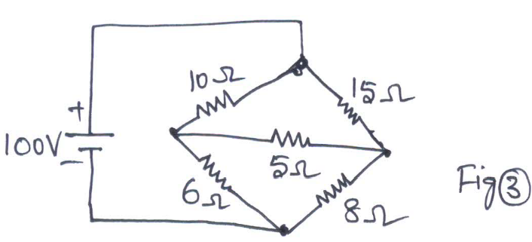 | [6M]
15. | a) | Derive the hybrid parameters in terms of Z-parameters | [4M]
 | b) | The Z-Parameters of a two pot network are Z₁₁=10Ω, Z₂₂=15Ω, Z₁₂=Z₂₁=5Ω. Find the equivalent T-network and ABCD-parameters. | [6M]
16. | a) | Derive the expression for transient response of series R-L circuit driven by sinusoidal excitation. | [4M]
 | b) | Derive the equation for the instantaneous current flowing through an inductor for t>0 when a series R-L circuit is excited with a D.C. voltage of V volts at t=0. | [6M]
17. | a) | State and explain Reciprocity theorem | [4M]
 | b) | What load resistance must be connected across A and B in below Fig. 4 to obtain maximum power.  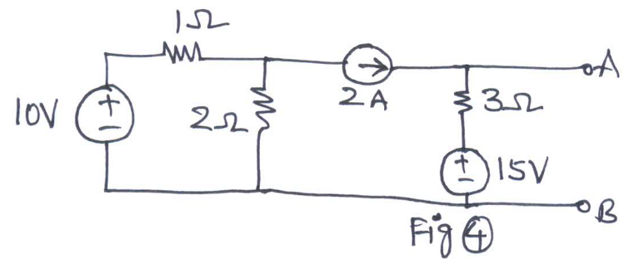 | [6M]
18. | a) | Explain the procedure to obtain the fundamental tie set matrix of a given network. | [4M]
 | b) | Draw the dual of the network given in Fig.5 below.  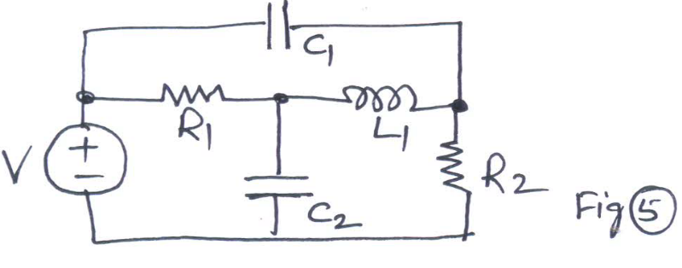 | [6M]
-- 00 -- 00 –

